
KITH AND KIN INTERNATIONAL COLLEGE
7/11 Kaoli Olusanya Street, Owode Ibeshe, Ikorodu, Lagos State.
THIRD TERM EXAMINATION 2024/2025 ACADEMIC SESSION

NAME
SUBJECT | MATHEMATICS | CLASS | SS 2 | DURATION | 2½ HOURS

THEORY
(100 Marks)

INSTRUCTIONS

- Write your name in the space provided at the top of this question.
- This paper is divided into two Parts: A and B.
- Answer 10 questions; all in Part A, and five questions from Part B.

PART A

Attempt all questions in this part.

- (a) Without using tables or calculator, simplify $\frac{0.6 × 32 × 0.004}{1.2 ×0.008 × 0.16}$, leaving the answer in standard form
(scientific notation).
(b) Simplify :$3\sqrt{75}-\sqrt{12}+ \sqrt{108}$ , leaving the answer in surd form (radicals).
WAEC 2014/1 (8 marks)
- A carpenter was told to make a rectangular desk with top of dimension 50 cm by 40 cm. The
carpenter actually made the desk 60 cm by 35 cm.
- Calculate the percentage error in the;
- length and the breadth
- area of the table top.
- Find the product of the two errors in (a)(i) WAEC 1990/4 (8 marks)

- (a) The graph of $y=2px^{2}-p^{2}x-14$ passes through the point$\left(3,10\right)$. Find the values of$p$.
(b) Two lines, $3y -2x=21$ and $4y+5x=5$ intersect at the point$Q$. Find the coordinates of $Q$.
NECO 2018/2 (8 marks)

4. A boy 1.2m tall, stands 6m away from the foot of a vertical lamp pole 4.2m long. If the lamp is at the
tip of the pole,
(a) represent this information in a diagram ;
(b) calculate the (i) length of the shadow of the boy cast by the lamp ; (ii) angle of elevation of the lamp
from the boy, correct to the nearest degree. WAEC 2013/5 (8 marks)

5.

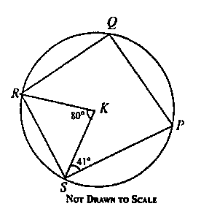
In the diagram above, P, Q , R, and S are points on the circle with centre K. KR is a bisector of angle
∠SRQ, ∠KSP $=41°$ , and ∠SKR $=80°$.
(a) Find: ∠RQP;
(b) Find ∠SPQ WAEC 2023/5 (8 marks)

PART B
Attempt five [5] questions only in this part.
6. PQ is a tangent to a circle RST at the point S. PRT is a straight line, < TPS = 34° and < TSQ = 65°.
(a) Illustrate the information in a diagram;
(b) find the value of : (i) < RTS ; (ii) < SRP.

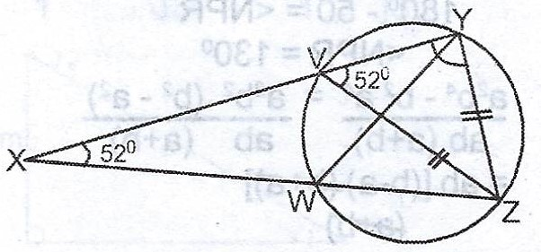
(c) In the diagram, /VZ/ = /YZ/, < YXZ = 20° and < ZVY = 52°. Calculate the size of < WYZ.

WAEC 2017/8 (12 marks)

7. A boy stands at the point M on the same horizontal level as the foot, T of a vertical building. He observes
an object on the top, P of the building at an angle of elevation of 66°. He moves directly backward to a
new point C and observes the same object at an angle of 53°. if | MT | = 50 m:
- Illustrate the information in a diagram;
- (i) Calculate and correct to one decimal place: the height of the building;
(ii) Calculate and correct to one decimal place: LINE MC. WAEC 2023/5
- The product of two consecutive positive numbers is 195. By constructing a quadratic equation and
solving It, find the two numbers. WAEC 1995/7 (12 marks)

8. (a) The height, h m, of a dock above sea level is given by $h=6+4\cos\left(15p\right)°,0<p<6$.
Find :
(i) the value of $h$ when $p=4$ ; (ii) correct to two significant figures, the value of $p$ when $h=9m$.
(b) Determine the value of $x$ for which the following expression is undefined ;
$\frac{7}{5x} - \frac{3x - 4}{{6x}^{2} - 3x + 30} + \frac{x^{2}+ 5}{64 - {4x}^{2}}$ WAEC 2015/4 (12 marks)

9. (a) The probabilities that three boys pass an examination are $\frac{2}{3}$, $\frac{5}{8}$ and $\frac{3}{4}$ respectively. Find the
probability that :
(i) all three boys pass ; (ii) none of the boys pass ; (iii) only two of the boys pass. WAEC 2001/9
(b) Given the points $P\left(3,5\right)$ and $Q\left(-5,7\right)$ on the Cartesian plane such that $R\left(x,y\right)$ is the midpoint
of $PQ$, find the equation of the line that passes through $R$ and perpendicular to line $PQ$.
WAEC 1993/4 (12 marks)
10. The table shows the marks scored by some candidates in an examination.
Marks (%) | 0-9 | 10-19 | 20-29 | 30-39 | 40-49 | 50-59 | 60-69 | 70-79 | 80-89 | 90-99
Frequency | 7 | 11 | 17 | 20 | 29 | 34 | 30 | 25 | 21 | 6
(a) Construct a cumulative frequency table for the distribution and draw a cumulative frequency curve.
(b) Use the curve to estimate, correct to one decimal place, the :
(i) Lowest mark for distinction if 5% of the candidates passed with distinction ;
(ii) probability of selecting a candidate who scored at most 45%.
NECO 2015/10 (12 marks)
11. (a) Y is 60 km away from X on a bearing of 135°. Z is 80 km away from X on a bearing of 225°. Find the :
(i) distance of Z from Y ;
(ii) bearing of Z from Y. WAEC 2007/4
- (i) The sum of the second and third terms of a geometric progression is six times the fourth term.
Find the two possible values of the common ratio.
(ii) If the second term is 8 and the common ratio is positive, find the first six terms.
NECO 2008/13 (12 marks)

12. (a) Copy and complete the table of values for $y=3sinx+2cosx$for $0°≤x≤360°$
$$x$$ | $$0°$$ | $$60°$$ | $$120°$$ | $$180°$$ | $$240°$$ | $$300°$$ | $$360°$$
$$y$$ | $$2.00$$ |  |  |  |  |  | $$2.00$$
(b) Using a scale of 2 cm to 60° on x- axis and 2 cm to 1 unit on the y- axis, draw the graph of
$y=3sinx+2cosx$ for $0°≤x≤360°$
(c) Use your graph to solve the equation : $3sinx+2cosx=1.5$.
(d) Find the range of values of x for which $3sinx+2cosx<-1$. WAEC 2008/12 (12 marks)


KITH AND KIN INTERNATIONAL COLLEGE
7/11 Kaoli Olusanya Street, Owode Ibeshe, Ikorodu, Lagos State.
THIRD TERM EXAMINATION 2024/2025 ACADEMIC SESSION

NAME
SUBJECT | MATHEMATICS | CLASS | SS 2 | DURATION | 1$\frac{1}{2}$HOURS
OBJECTIVE TEST
(50 marks)
Answer all questions
Each question is followed by four options lettered A to D. Choose the correct option for each question and shade in pencil on your answer sheet the answer space that bears the same letter as the option you have chosen. Give only one answer to each question and erase completely any answer you wish to change. Do all rough work on this question paper.

- If $\log_{10}2=m$ and $\log_{10}3=n$, find the $\log_{10}24$ in terms of $m$ and $n.$
  - 3$m+n$
  - $m+3n$
  - 4$mn$
  - 3$mn$

- If $log$ 2 $=$0.3010 and $log{ 2}^{y}=$ 1.8062, find correct to the nearest whole number, the value of $y$.
  - 6
  - 5
  - 4
  - $-5$

- A student found the approximate value of 0.02548 correct to two decimal places instead on two significant figures. Find the percentage error.
  - $0 \%$
  - $13\frac{1}{3}\%$
  - $16\frac{2}{3}\%$
  - $20 \%$

- Two buses start from the same station at 9:00 am, and travel in opposite directions along the same straight road. The first bus travels at a speed of 72 km/h and the second at 48 km/h. At what time will they be 240 km apart?
  - 1:00 pm
  - 12:00 noon
  - 11:00am
  - 10:00 am

- The n^{th} term of a sequence is
T_{n} = 5 + (n - 1)2. Evaluate T4 - T6
  - $30$
  - $16$
  - $-16$
  - $-30$

- If Olu, Tony and Tunde share ₦240 000.00 in the ratio 2 : 3 : 5 respectively, what is two-thirds of Tunde’s share?
  - ₦120 000.00
  - ₦80 000.00
  - ₦72 000.00
  - ₦48 000.00

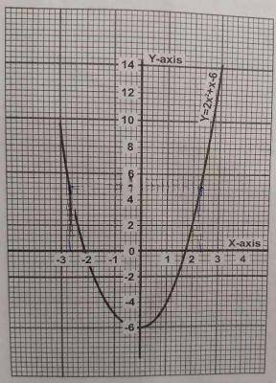
From the graph determine the roots of the
equation $y={2x}^{2}+x-6$
A.$-3$ , 4
B. $-2$,$1.5$
C. $-1$, $1$
D. 2, 1.5

- If twice a certain integer is subtracted from 5 times the integer, the result is 63. Find the integer.
  - 35
  - 21
  - 4
  - 3

- Simplify $\frac{1}{ x - 3} - \frac{\left( x - 1\right)}{x^{2}- 9}$

- $\frac{x-1}{x - 3}$
- $\frac{2 }{x + 3}$
- $\frac{x - 1}{x + 3}$
- $\frac{4x}{x^{3 }- 9}$

- The ratio of the number of men to the number of women in a 20-member committee is 3 : 1. How many women must be added to the 20-member committee so as to make the ratio of men to women 3 : 2?
  - 2
  - 5
  - 7
  - 9

- If the 2nd and 5th terms of a G.P are 6 and 48 respectively, find the sum of the first four terms.
  - $-15$
  - 15
  - 33
  - 45

- A ladder 9 m long leans against a vertical wall, making an angle of 64$°$ with the horizontal ground. Calculate correct to one decimal place, how far the foot of ladder is from the wall.
A. 4.0 m
B. 5.8 m
C. 7.1 m
D. 8.1 m

- Factorize $5y^{2}+2ay-3a^{2}$
  - $\left(5y-a\right)\left(y+3a\right)$
  - $\left(5y+a\right)\left(y-3a\right)$
  - $\left(y-a\right)\left(5y+3a\right)$
  - $\left(y+a\right)\left(5y-3a\right)$

- If $\frac{3^{(1-n)}}{9^{-2n}} = \frac{1}{9}$ find $n$
  - $-\frac{3}{2}$
  - $\frac{1}{3}$
  - $-1$
  - $-3$

- Given that $4P4_{5}={119}_{10}$ , find the value $P.$
A. 1
B. 2
C. 3
D. 4

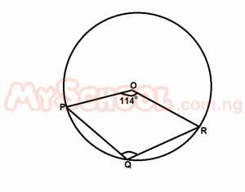
In the diagram above, O is the center
of the circle. If ∠POR = 114º,
calculate ∠PQR
A. 134º
B. 123º
C. 117º
D. 114º

18. Evaluate ${\left(101.2\right)}^{2}-{\left(100.5\right)}^{2}$
A. 1
B. 202
C. 20.02
D. 2.02

19. If $\sin{θ=k, }$ find $\tan{θ}, 0°≤θ≤90°$
  - $1-k$
  - $\frac{k}{\sqrt{{ 1 - k}^{2}}}$
  - $\frac{k}{1-k }$
  - $\frac{k}{k - 1}$
- $cos x$is negative and $\sin{x}$ is
negative. Which of the following is
true of $x?$
A. $90°<θ<180°$
B. $180°<θ<270°$
C.$270°<θ<360°$
D. $0°<θ<90°$

- The fourth term of an exponential
sequence is 192 and its ninth term is
6. Find the common ratio of the
sequence.
  - $\frac{1}{3}$
  - $\frac{1}{2}$
  - 2
  - 3
- Given that $-6$,$2\frac{1}{2}$,… 71 is linear
sequence, calculate the number of
the terms in the sequence.
A. 20
B. 23
C. 22
D. 21

- The expression $\frac{5x+3}{6x\left(x+1\right)}$ will be
undefined when $x$ equals
  - $\left(0, 1\right)$
  - $\left(0, -1\right)$
  - $\left(-3, -1\right)$
  - $\left(-3, 0\right)$
- The 1st term of a geometric progression (G.P) is $\frac{3}{4}$ , if the product of the 2nd and 3rd terms of the sequence is 972, find its common ratio.
- 3
- 12
- 36
- 45

25. Simplify $\frac{{2x}^{2}-5x-12}{{4x}^{2}-9}$
A. $\frac{x + 4}{2x + 3}$
B. $\frac{x - 4}{2x - 3}$
C. $\frac{x - 4}{2x + 3}$
D. $\frac{x + 4}{2x - 3}$
26. If $x^{2}+15x+50=a^{2 }+bx+c=0.$
Which of the following statements is
not true?
A. $x= -5$
B. $bc =750$
C. $x+10=0$
D. $x=10$

27. Given that $\left(2x+7\right)$ is a factor of ${2x}^{2}+3x-14$, find the other factor.
A. $x+2$
B. $x-2$
C. $2-x$
D. $x+1$

28. If $\frac{4m+3n}{4m-3n}= \frac{5}{2}$ , Find the ratio of $m:n$
- 4 : 3
- 7 : 4
- 3 : 4
- 4 : 7

29. Factorize ${6x}^{2}+7x-20$
A. $\left(6x-5\right)\left(x+4\right)$
B. $\left(3x-4\right)\left(2x+5\right)$
C. $\left(3x+4\right)\left(2x-5\right)$
D. $2\left(3x-5\right)\left(x+2\right)$

30. The truth set of $8+2x-x^{2}=0$ is $\left(p,q\right)$. Evaluate $p+q$.
A. $-6$
B. $2$
C. $-2$
D. 4

31. Find the roots of the equation
$y={3x}^{2}+x-7$.
A. 1.0 and $-1.2$
B. 1.1 and $-1.3$
C. 1.4 and $-1.7$
D. 2.0 and $-1.9$

    - A box contains 13 currency notes, all
of which are either ₦50 or ₦20 notes.
The total value of the currency notes
is ₦530. How many ₦50 notes are in
the box?
A. 4
B. 6
C. 9
D. 10
33. Solve ${\left(\frac{1}{9}\right)}^{x+2}={243}^{x-2}$
A. $x= \frac{7}{6}$
B.$x= -\frac{6}{7}$
C. $x = \frac{6}{7}$
D. $x=-\frac{7}{6}$
34. A casting is made up of copper and
zinc. If 65$\%$ of the casting is zinc and there are 147 g of copper, what is the mass of the casting?
A. 320 g
B. 400 g
C. 420 g
D. 350 g

35. Determine the value of x for which
$\left(x^{2}-1\right)>0$ ?
A. $x>0$
B. $-1<x<1$
C. $x<-1$ or $x>1$
D. $x<-1$

36. Find the range of values of $x$ for which $3x-7≤0$ and $x+5>0$?
A. $-5<x<\frac{7}{3}$
B. $-5≤x≤\frac{7}{3}$
C. $-5≤x<\frac{7}{3}$
D. $-5<x≤\frac{7}{3}$
37.
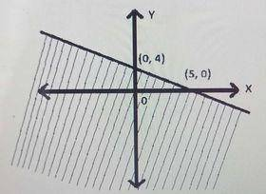
Which inequality describes the graph
above?
A. $4y+5x≥20$
B. $5y+4x≥20$
C. $5y+4x≤20$
D. $4y+5x≤20$

38. In a bag of oranges, the ratio of the
good ones to the bad ones in the bag
is 5 : 4, if the number of the bad
oranges in the bag is 36, how many
oranges are there altogether?
A. 81
B. 72
C. 54
D. 45

39. If the angle of a sector of a circle of
diameter 8cm is 135°. Find the area
of the sector [Take π = $\frac{22}{7}$].
A. $9\frac{3}{7}{cm}^{2}$
B. $12\frac{4}{7}{cm}^{2}$
C. $18\frac{6}{7}{cm}^{2}$
D. $25\frac{1}{4}{cm}^{2}$
40.
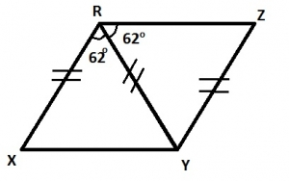
In the diagram above, |XR| = |RY| =
|YZ| and ∠XRY = ∠YRZ $=62°$,
Calculate ∠XYZ.
A. $50°$
B. $62°$
C. $115°$
D. $150°$

41. The angle of elevation of the top of a cliff
15 meters high from a landmark is 60º.
How far is the landmark from the foot of
the cliff? Leave your answer in surd form
A. $15\sqrt{3} m$
B. $15\sqrt{2} m$
C. $5\sqrt{3} m$
D. $10\sqrt{3} m$

42. A ladder $5 m$ long long rest against a
wall such that its foot makes an angle
$30°$ wih the horizontal. How far is the
foot of the ladder from the wall?
A. 5 $\frac{\sqrt{3}}{3}m$
B. $2\frac{1}{2}m$
C. 5 $\frac{\sqrt{3}}{2}m$
D. 10 $\frac{\sqrt{3}}{3}m$
43. 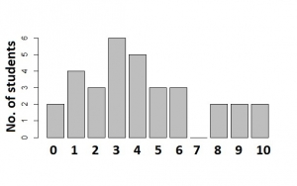
The bar chart above shows the distribution of
marks scored by a group of students in a test.
Use the chart to answer the question below
How many students took the test?
A. 38
B. 32
C. 15
D. 11
44.
Class | $$1-3$$ | $$4-6$$ | $$7-9$$
Frequency | $$5$$ | $$8$$ | $$5$$
Find the standard deviation of the data
using the table above
A. $5$
B. $\sqrt{5}$
C. $\frac{5}{3}$
D. $\sqrt{6}$
45. The mean of ten positive numbers is 16.
When another number is added, the mean
becomes 18. Find the eleventh number
A. 3
B. 38
C. 30
D. 40

46. If the mean of $2$, $5$, $\left(x+1\right)$, $\left(x+2\right)$, $7$ and
$9$ is $6$.
Find the median
A. $5.5$
B. $6.5$
C. $6$
D. $5$

47. A bag contains 3 white, 6 red and 5
blue identical balls. A ball is picked at
random from the bag. What is the
probability that it is either white or
blue?
- $\frac{9}{14}$
B.$\frac{4}{7}$
C. $\frac{4}{15}$
D. $\frac{3}{14}$

48. The probability of picking a letter T from the
word OBSTRUCTION is?
A. $\frac{1}{10}$
B. $\frac{1}{11}$
C. $\frac{2}{11}$
D. $\frac{3}{11}$

49. The probability of a student passing
any examination is $\frac{2}{3}$. If the students
takes three examination, what is the
probability that he will not pass any of
them?
A. $\frac{2}{3}$
B. $\frac{1}{27}$
C. $\frac{8}{27}$
D. $\frac{4}{9}$
50. Two numbers are removed at random
from the numbers 1, 2, 3 and 4. What is
the probability that the sum of the
numbers removed is even?
A. $\frac{2}{3}$
B. $\frac{1}{2}$
C. $\frac{3}{4}$
D. $\frac{2}{5}$

